  crowdhum.com | CrowdHum · CrowdHum  Team Change-Readiness Workshop  Session recap · April 8, 2026 · 62 participants · 5 polls

1. Session overview
Give managers a clear story this week — credibility before more announcements.
Stop one initiative this week and assign Comms + HR to deliver a manager story and decision-rights pack within 7 days. The room asked for a visible cut first — 'visibly stop something' leads at 22% (6pp over 'name the trade-offs' at 16%) — while managers are the widest gap at 31% and front-line clarity lags at 24%. Managers specifically need 'A clear story they can tell their team' at 31% (with 'Decision rights…' another 20%), and readiness skews wary (cautious 23%, with confused 15% and tired 11%), so credibility plus clarity beats more announcements. Lock a single urgency narrative to anchor that pack — the rationale is near-tied (customer outcomes 33% vs scaling 28%) — and name owners in the next exec update.
2. What the room voted on
Each poll is reported with its facilitator-framed question, the leading response, and the spread across the next responses. Percentages reflect share of votes cast on that poll only.
1. Two-cluster split on readiness, anxious terms dominant (cautious 23%; confused+tired 26%) — mirror it and pair with a visible stop.
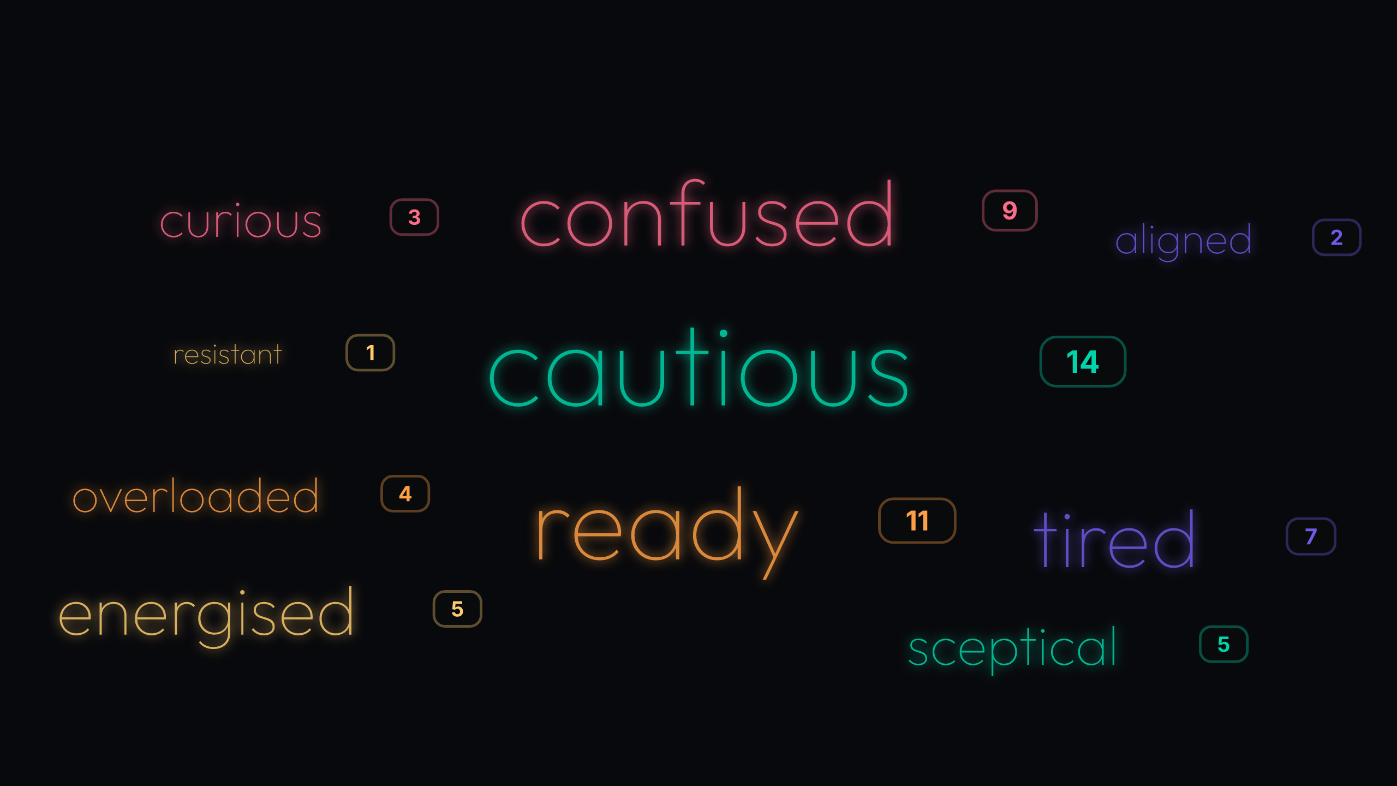
Poll 1: 61 votes
Readiness is mixed and leans wary: 'cautious' leads at 23% (5pp over 'ready' at 18%), with 'confused' (15%) and 'tired' (11%) reinforcing anxiety. Positive energy exists ('ready' 18%, 'energised' 8%), but it's smaller; outright 'resistant' is marginal at 2%. Treat this as a temperature read, not a mandate: acknowledge caution and fatigue, then make one credibility move to shift the mood. Treat as: mirror the ambivalence and name one concrete move that reduces load. Mirror the 'cautious/confused/tired' cluster at the next all-hands and state one specific thing that will stop this week.
2. Managers-as-bottleneck holds a moderate lead at 31% (7pp over front-line clarity) — commit a 30‑day enablement sprint.
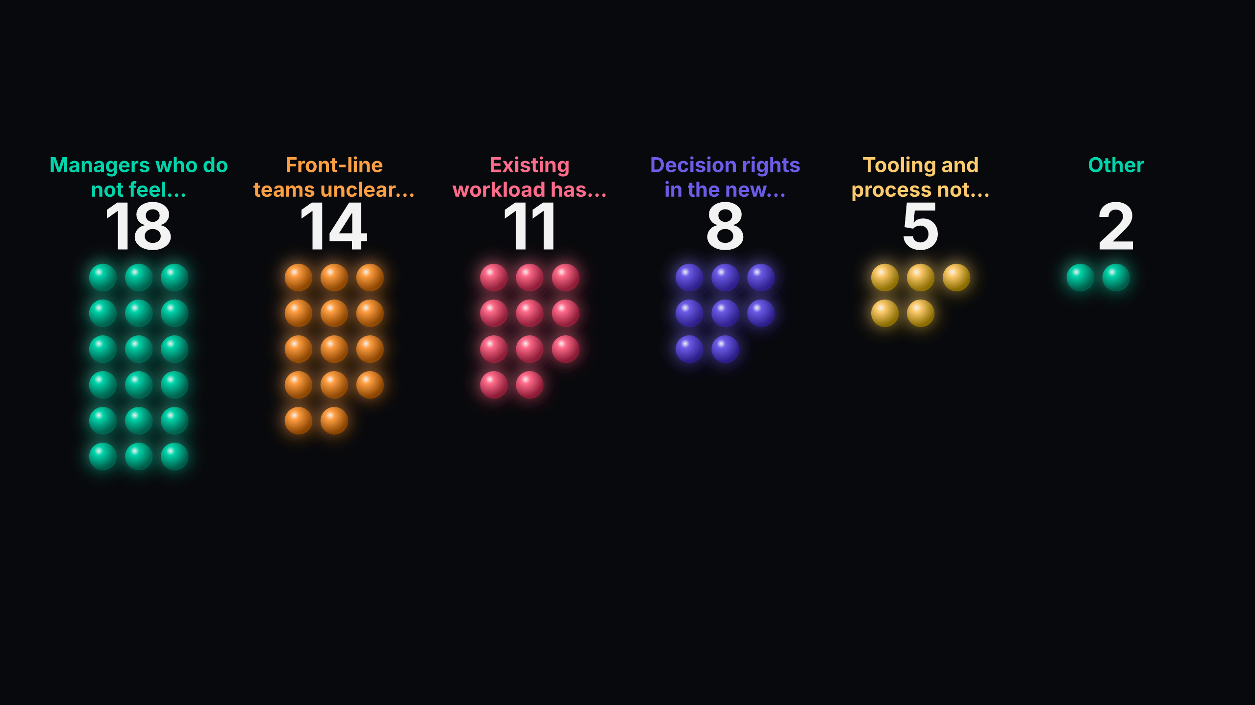
Poll 2: 58 votes
Enablement for managers is the widest gap at 31% (7pp over front-line clarity at 24%), with capacity drag present ('Existing workload has not been reduced' at 19%). Directional signal, not consensus, but strong enough to act; 'Tooling and process not ready yet' is smaller at 9%. Treat as: commit to a 30‑day manager enablement sprint focused on leading this change. Commit a 30‑day manager enablement sprint (owner: L&D/Operations) starting this week; name the accountable owner today.
3. Near-tie at the top (33% vs 28%) — pick one primary narrative for urgency before rollout.
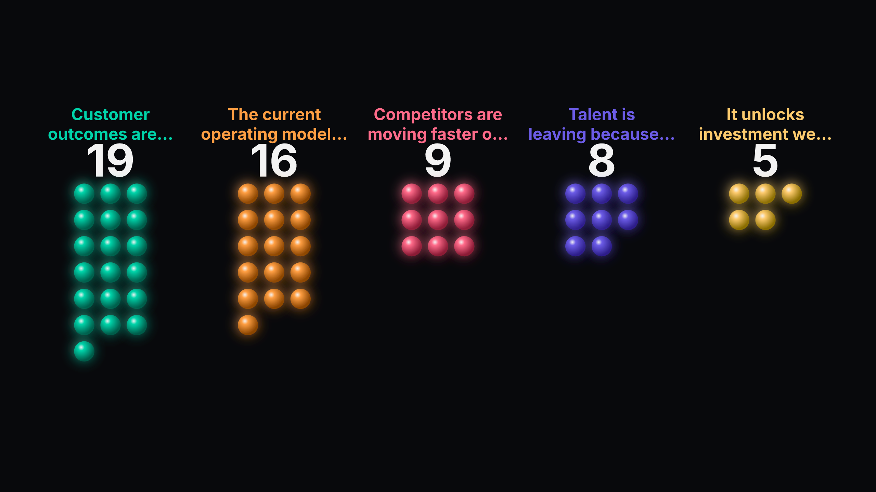
Poll 3: 57 votes
Two urgency narratives are effectively co-equal: 'Customer outcomes are slipping' at 33% vs 'The current operating model is no longer scaling' at 28% (5pp). Market and talent arguments trail (16% and 14%), and 'It unlocks investment...' is lowest at 9%. Mixed storylines will dilute manager messaging. Treat as: arbitrate the single lead narrative to anchor all comms. Arbitrate the primary rationale — choose 'Customer outcomes are slipping' or 'The current operating model is no longer scaling' — and brief managers by Friday.
4. Moderate lead for 'a clear story' at 31%, with 'decision rights' close behind — ship a manager story + rights pack.
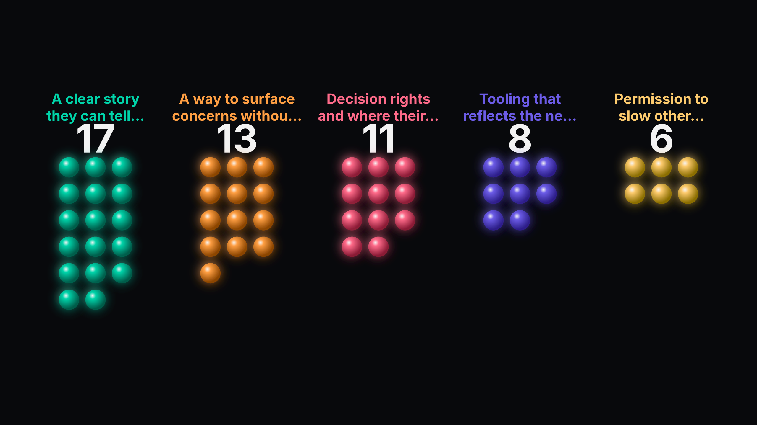
Poll 4: 55 votes
Managers first need 'A clear story they can tell their team' at 31% (7pp over 'A way to surface concerns...' at 24%), with 'Decision rights and where their authority actually starts' substantial at 20%. Mechanics trail (tooling 15%, permission to slow 11%), so equip managers before tooling. This aligns with the enablement gap earlier. Treat as: commit to produce and distribute a story + decision-rights pack within 7 days. Assign Comms + HR to ship a one‑pager with 'A clear story they can tell their team' and 'Decision rights and where their authority actually starts' within 7 days.
5. Visible-stop ask pulls a moderate lead at 22% (6pp over trade‑offs) — make one public cut this week.
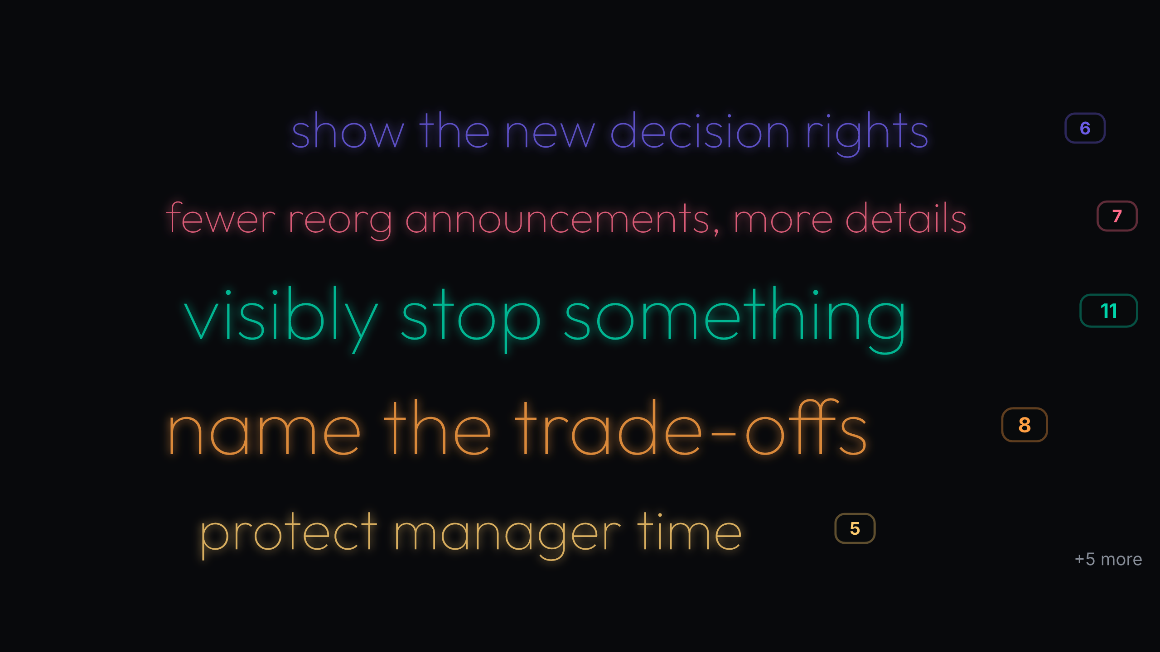
Poll 5: 51 votes
'Visibly stop something' leads at 22% (6pp over 'name the trade-offs' at 16%), with calls for substance ('fewer reorg announcements, more details' at 14%) and decision-rights transparency at 12%. Smaller asks like 'cancel a recurring meeting' (4%) and 'a clear no on something' (4%) show appetite for micro-cuts too. The room is asking for credibility through subtraction, then clarity. Treat as: commit to kill one initiative publicly within 7 days and explain the trade-offs. Kill one initiative publicly this week and explain the trade-offs in the same update.
3. Where the room aligned
These cross-poll patterns are the clearest signals to act on.
• A visible stop is the fastest way to buy credibility and free manager time (high confidence). The ask to 'visibly stop something' lands highest, workload is still unreduced, and readiness shows fatigue; a public cut addresses all three at once.. So what: Commit to kill one initiative this week and say which manager hours it frees. Evidence: visibly stop something — 22% (11/51); Existing workload has not been reduced — 19% (11/58); tired — 11% (7/61); overloaded — 7% (4/61).
• Manager comms kit is the unlock for execution (high confidence). Managers are the widest gap and their top need is a clear story, with decision-rights close behind; equip them before tooling.. So what: Assign Comms + HR to ship a story + decision-rights pack within 7 days. Evidence: Managers who do not feel equipped to lead it — 31% (18/58); A clear story they can tell their team — 31% (17/55); Decision rights and where their authority actually starts — 20% (11/55).
• Split rationale explains hesitant readiness (medium confidence). Two near-tied urgency stories create ambiguity, and the mood leans cautious; picking one narrative will help managers transmit confidence.. So what: Arbitrate the primary rationale and embed it in the manager story. Evidence: Customer outcomes are slipping in the current model — 33% (19/57); The current operating model is no longer scaling — 28% (16/57); cautious — 23% (14/61).
4. Where the room split
Credibility move vs capacity drag: Without a real cut, the change looks like more work layered onto full plates. Destination clarity vs split urgency narrative: Managers cannot tell a compelling story if leadership runs two rationales in parallel. Authority ambiguity vs manager enablement: If decision rights stay opaque, managers will hesitate regardless of training.
• Credibility move vs capacity drag: Without a real cut, the change looks like more work layered onto full plates. (high confidence). How to frame it: Operational: decide what to stop now; Reflective: acknowledge fatigue and say what load comes off this week. Evidence: visibly stop something — 22% (11/51); Existing workload has not been reduced — 19% (11/58); tired — 11% (7/61); overloaded — 7% (4/61).
• Destination clarity vs split urgency narrative: Managers cannot tell a compelling story if leadership runs two rationales in parallel. (high confidence). How to frame it: Decide the primary narrative for the next 30 days, then bake it into the manager story. Evidence: A clear story they can tell their team — 31% (17/55); Customer outcomes are slipping in the current model — 33% (19/57); The current operating model is no longer scaling — 28% (16/57); Front-line teams unclear on what changes for them — 24% (14/58).
• Authority ambiguity vs manager enablement: If decision rights stay opaque, managers will hesitate regardless of training. (medium confidence). How to frame it: Operational: publish a one‑page decision‑rights map alongside the story; Reflective: invite managers to flag grey zones. Evidence: Decision rights and where their authority actually starts — 20% (11/55); Decision rights in the new model — 14% (8/58); show the new decision rights — 12% (6/51).
5. Next steps
5.1 Suggested directions
Based on the room's input, the team might consider:
• Name the single initiative we will stop this week to free manager time.
• Validate the split back to the org at Thursday’s all-hands; name 'cautious' and 'ready' and announce one stop you will make this week.
• Draft and approve a 30‑day enablement plan by Monday (owner: L&D lead) covering 'A clear story they can tell their team' and 'Decision rights and where their authority actually starts'.
• Write a two‑sentence urgency narrative (owner: Strategy lead), test with 3 managers tomorrow, and lock it by Friday.
5.2 Specific commitments from the room
Use this space to record what your team agreed to in the room — owners, dates, and follow-ups CrowdHum couldn't see.

