  crowdhum.com | CrowdHum · CrowdHum  Client Strategy Offsite — 2026 Direction  Session recap · April 22, 2026 · 48 participants · 5 polls

1. Session overview
Stop one initiative this week and name owners for the top three priorities.
Stop one active initiative this week and publish the cut; then name single-threaded owners for the top three priorities within 30 days. Capacity is the top execution risk at 32%, the unsaid constraint is “we won’t stop anything” at 25%, and the room’s fastest confidence boost is “agree on what we stop doing” at 35% — the ask is for a real cut, not a message. Confidence in pillars is near-tied (29% vs 24% vs 20%), which explains why ownership clarity (26%) is the second-best confidence move; without owners, the split turns into drift. The mood is “ambitious” (26%) but “stretched” (19%), so a visible stop converts energy into credibility. Announce the stop in the next exec update (CEO), and publish the owners and freed capacity by Friday (Chief of Staff to drive, COO to execute).
2. What the room voted on
Each poll is reported with its facilitator-framed question, the leading response, and the spread across the next responses. Percentages reflect share of votes cast on that poll only.
1. Two-cluster split (ambitious 26% vs stretched 19%) — energy is real but strain argues for a visible stop.
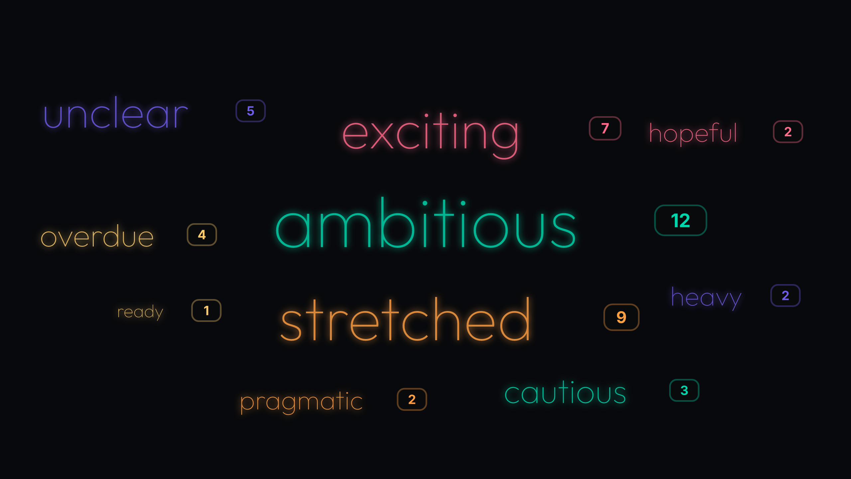
Poll 1: 47 votes
Mood is upbeat and big (“ambitious” at 26%, “exciting” at 15%), yet a sizeable strain signal sits right behind it (“stretched” at 19%). Clarity isn’t settled (“unclear” at 11%), which helps explain why optimism hasn’t translated into easy choices. Treat as: commit to a visible stop decision to convert energy into credibility. Commit to a visible stop decision now to turn optimism into execution credibility.
2. Capacity risk holds a moderate lead at 32% (9pp over ‘Unclear priorities’) — cut scope or execution slips.
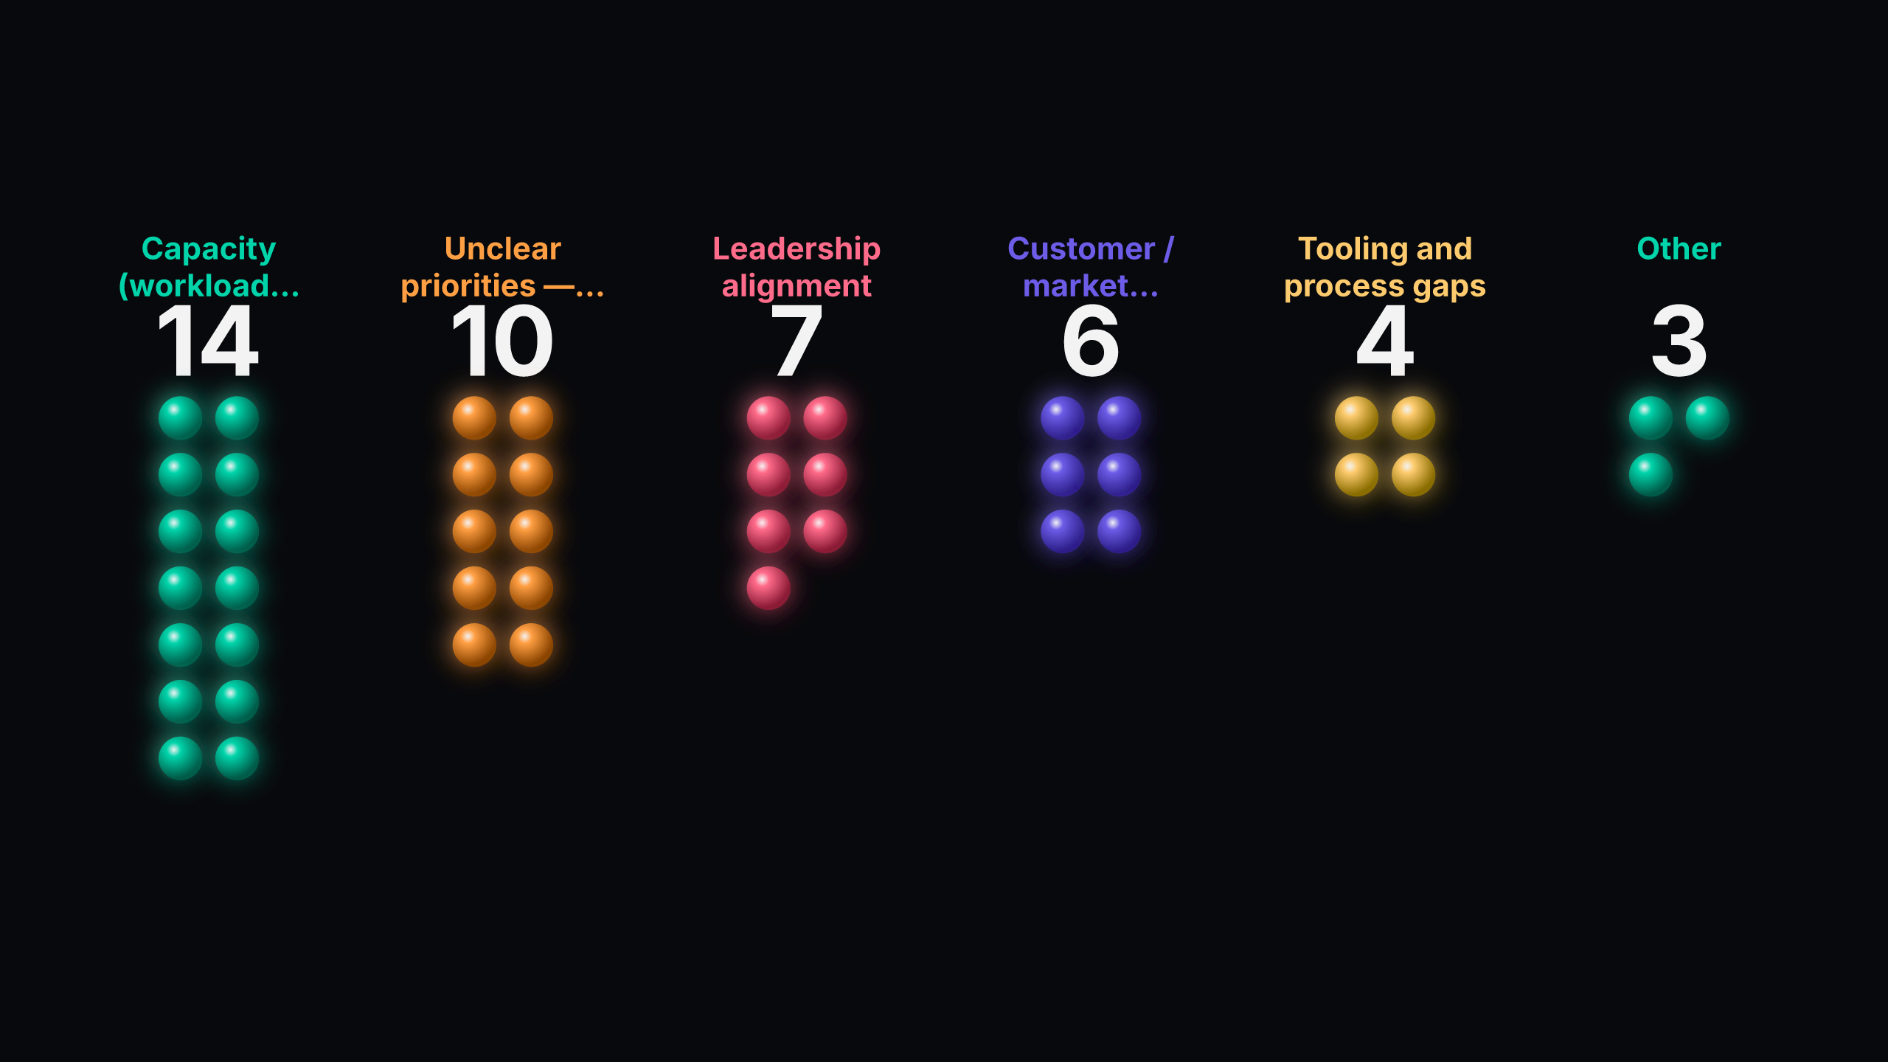
Poll 2: 44 votes
Execution risk is primarily about people capacity (32%), with diffuse priorities close behind (23%) and alignment third (16%). Tooling (9%) and market uncertainty (14%) matter but are secondary. The risk stack pairs directly with the unsaid constraint that we won’t stop anything. Treat as: commit to stop work and reset hiring/timeline assumptions. Commit to cut at least one active initiative this week and publish the capacity freed; adjust the hiring/timeline plan accordingly.
3. Near-tie at the top (29% vs 24%) — no clear winner; decide which pillar gets H2 headcount first.
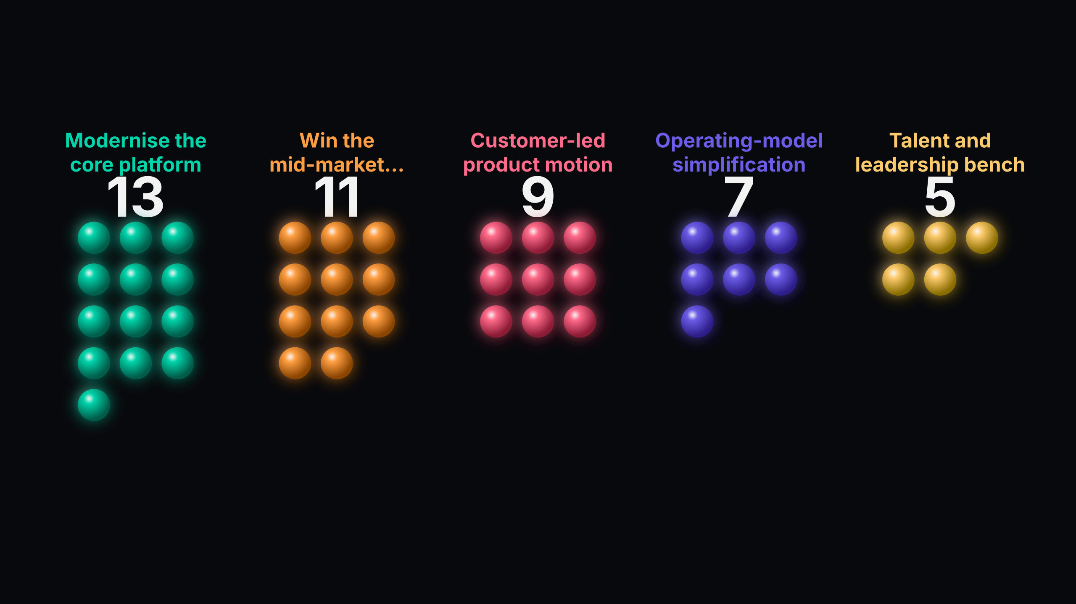
Poll 3: 45 votes
Confidence clusters across three pillars (“Modernise the core platform” 29%, “Win the mid-market segment” 24%, “Customer-led product motion” 20%). That split means there’s no natural single bet. “Talent and leadership bench” is decisively last at 11% (0.38x the leader), so don’t bank 2026 delivery on bench uplift without a separate plan. Treat as: arbitrate the resourcing sequence across the top three. Force-rank the top three pillars for H2 headcount and name a single accountable owner for #1.
4. “We won’t stop anything” pulls a moderate lead at 25% — credibility requires a decisive cut.
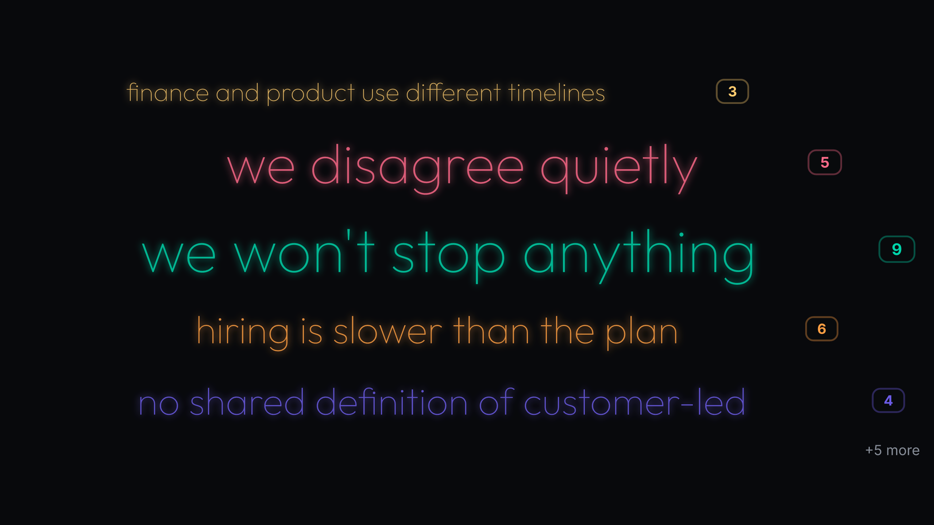
Poll 4: 36 votes
The unsaid constraint is permission: “we won’t stop anything” leads at 25%, with hiring lag (17%) and quiet disagreement (14%) close behind. Definition gaps (“no shared definition of customer-led” at 11%) and planning mismatches (finance vs product timelines at 8%) explain friction downstream. Treat as: commit to a visible stop and set a single planning cadence owner. Deprioritise one active initiative publicly and assign a single owner for the planning cadence to end the timeline split.
5. “Agree on what we stop doing” posts a moderate lead at 35%, with ownership next at 26% — schedule the stop call within 30 days.
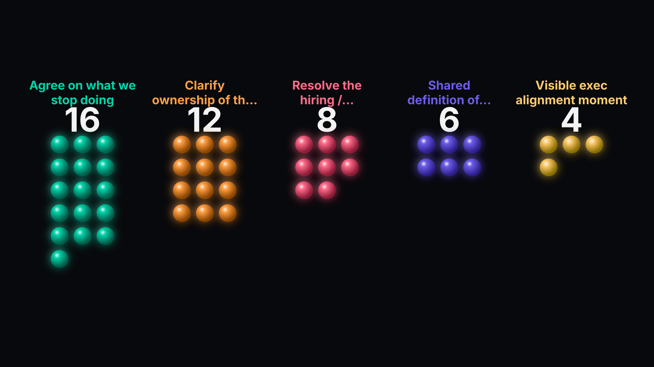
Poll 5: 46 votes
Confidence rises fastest with a concrete cut (35%), then by naming owners for the top three priorities (26%). Fixing hiring/timeline mismatch matters (17%), while a “visible exec alignment moment” at 9% signals talk without cuts won’t move confidence. Treat as: commit to a stop list now and assign owners in the same window. Commit to a published stop list and name single-threaded owners for the top three priorities within 30 days.
3. Where the room aligned
These cross-poll patterns are the clearest signals to act on.
• The room wants a real cut, not a signal (high confidence). Capacity is the top risk and the unsaid constraint is refusal to stop; the most confidence-increasing action is to agree what to stop.. So what: Commit to stop one initiative this week and publish the freed capacity. Evidence: Capacity (workload, hiring lag) — 32% (14/44); “we won't stop anything” — 25% (9/36); “Agree on what we stop doing” — 35% (16/46).
• Split confidence across pillars requires sequencing, not more debate (high confidence). Three pillars cluster at 29% / 24% / 20%, while ownership clarity is the second-ranked confidence move.. So what: Arbitrate the H2 headcount order across the top three and name owners today. Evidence: “Modernise the core platform” — 29% (13/45); “Win the mid-market segment” — 24% (11/45); “Customer-led product motion” — 20% (9/45); “Clarify ownership of the top three priorities” — 26% (12/46).
• Definition gaps threaten customer bets (medium confidence). A minority names “no shared definition of customer-led” while two customer-facing pillars carry 44% combined confidence.. So what: Arbitrate a single definition of “customer-led” and publish it with the owner assignments. Evidence: no shared definition of customer-led — 11% (4/36); “Win the mid-market segment” — 24% (11/45) + “Customer-led product motion” — 20% (9/45) — top 2 customer bets combine to 44%.
4. Where the room split
Ambition vs capacity: Energy is high, but without a stop decision the execution load remains unrealistic. Destination clarity vs execution ownership: Multiple attractive pillars without named owners leads to diffusion, not progress. Planning cadence split: Competing timelines waste capacity and undermine any stop decision’s impact.
• Ambition vs capacity: Energy is high, but without a stop decision the execution load remains unrealistic. (high confidence). How to frame it: Name the cut first; then ask which owner will absorb the freed scope and by when. Evidence: “ambitious” — 26% (12/47) vs “stretched” — 19% (9/47); Capacity (workload, hiring lag) — 32% (14/44); “we won't stop anything” — 25% (9/36).
• Destination clarity vs execution ownership: Multiple attractive pillars without named owners leads to diffusion, not progress. (high confidence). How to frame it: Force-rank the top three for H2 and name one accountable per pillar in the same sitting. Evidence: Near-tied pillars: 29% vs 24% vs 20% confidence across three options; “Clarify ownership of the top three priorities” — 26% (12/46); “we disagree quietly” — 14% (5/36).
• Planning cadence split: Competing timelines waste capacity and undermine any stop decision’s impact. (medium confidence). How to frame it: Assign a single cadence owner and publish the unified calendar before owners start execution. Evidence: finance and product use different timelines — 8% (3/36); Resolve the hiring / timeline mismatch — 17% (8/46).
5. Next steps
5.1 Suggested directions
Based on the room's input, the team might consider:
• If we must deprioritise ONE 2026 pillar for this quarter, which one pauses first?
• Schedule a 30-minute stop-decision in the next exec update — CEO chairs; output is a single named initiative to cut and an effective date.
• Force-rank active initiatives by 'effort high/impact low' and name one to stop — COO + ELT by Friday; publish the freed capacity in FTE-weeks.
• Update the hiring/timeline plan to reflect current funnel reality — CHRO + Finance by next Tuesday; circulate deltas vs original plan.
5.2 Specific commitments from the room
Use this space to record what your team agreed to in the room — owners, dates, and follow-ups CrowdHum couldn't see.

