  crowdhum.com | CrowdHum · CrowdHum  Leadership Cohort — Mid-program Check-in  Session recap · April 15, 2026 · 24 participants · 5 polls

1. Session overview
Replace the next module with paired rehearsal of underperformer and manager‑boundary conversations.
Replace the next module’s content with paired rehearsal of two real conversations — an underperformer on my team and role boundaries with my manager — and open by validating permission to act. Avoidance clusters there (24% and 19%), while the biggest execution gap is waiting for permission at 39% (17pp over skill and capacity, both 22%), so confidence will come from doing. The cohort asked for practice first — peer rehearsal leads support at 33% (8pp over coaching at 25%) — and the mood is stretched/questioning (46%), which argues for reps and explicit agency over more theory. Pair participants this week, run one real conversation before the next session, and make progress visible with a quick debrief and a simple decision‑rights one‑pager shared by the facilitator.
2. What the room voted on
Each poll is reported with its facilitator-framed question, the leading response, and the spread across the next responses. Percentages reflect share of votes cast on that poll only.
1. Two-cluster split — strain words dominate 46% ('stretched' 25%, 'questioning' 21%) — normalize the load and pair people.
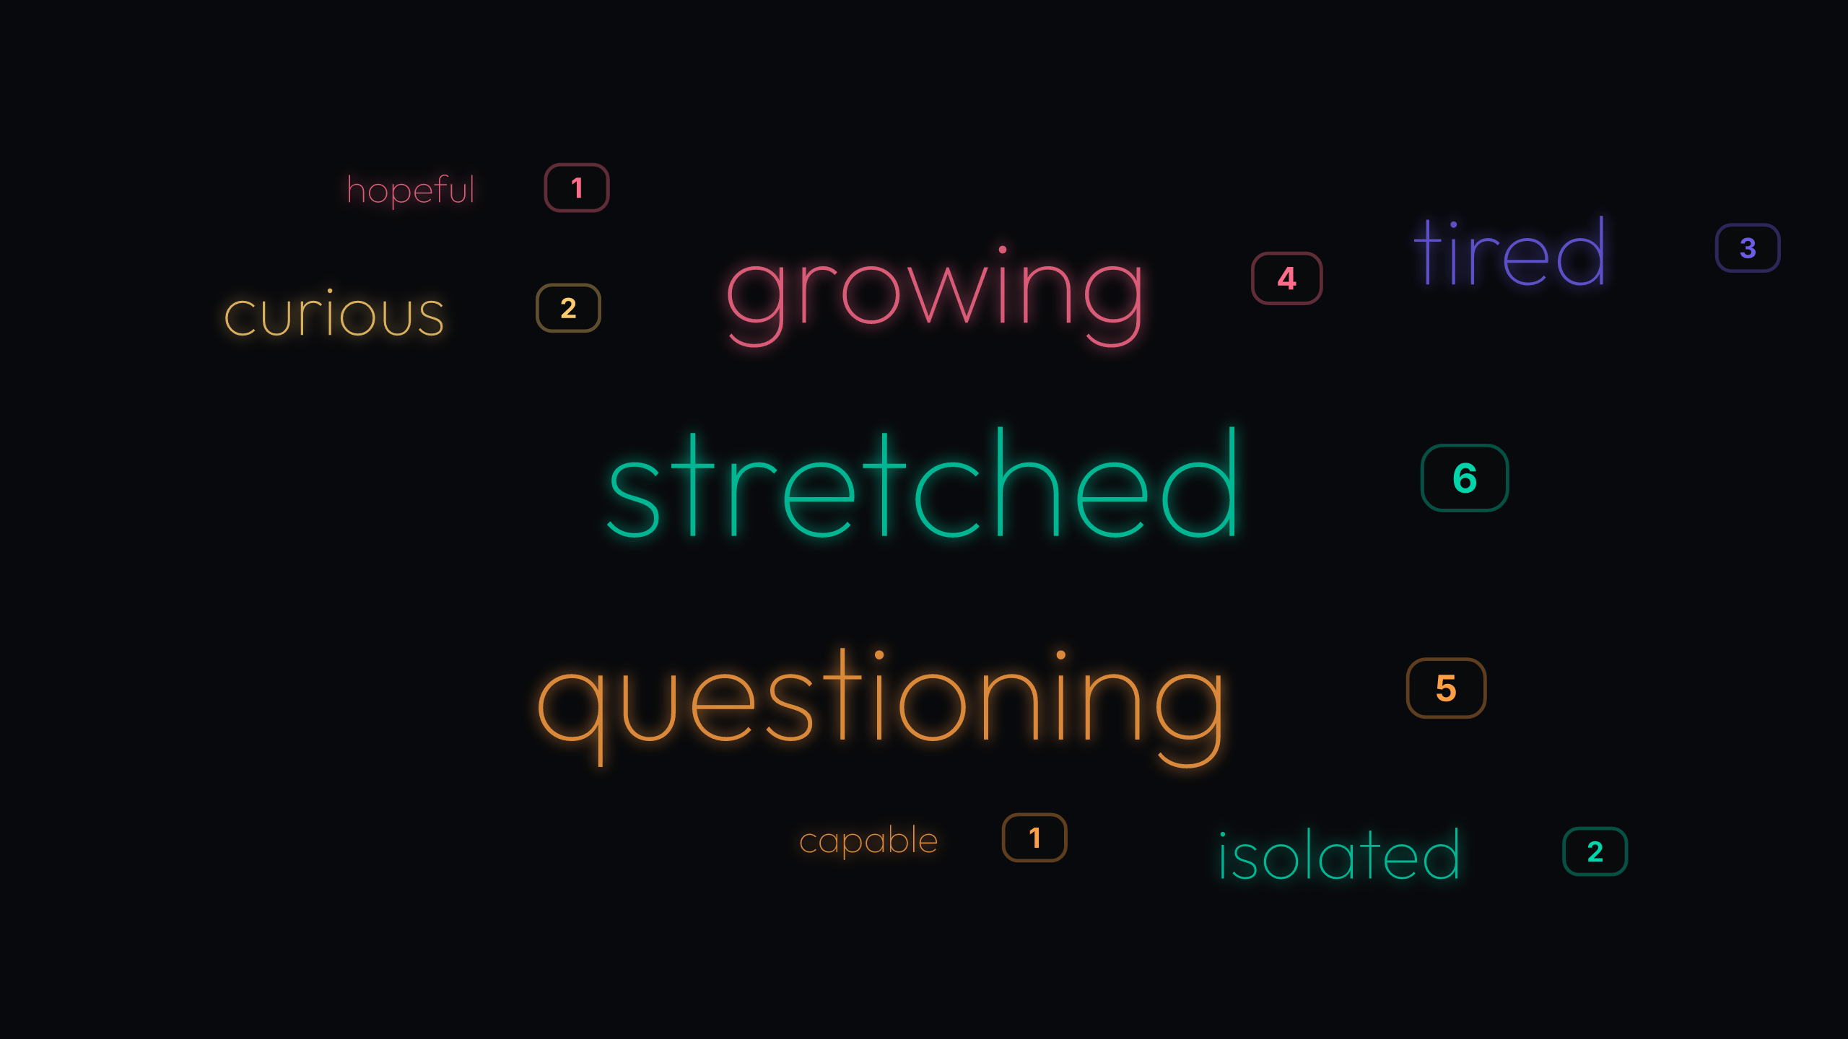
Poll 1: 24 votes
Emotional temperature skews strained, not defeated: 'stretched' (25%) and 'questioning' (21%) outweigh 'growing' (17%). 'Tired' (13%) and 'isolated' (8%) add an energy and connection gap. This tilt pairs with the later support ask for practice over theory, suggesting people want real help, not more models. Treat as: validate the strain and mirror the growth; pair for near-term support. Validate the two-cluster mood out loud, then pair participants for mutual support during the next 4 weeks.
2. Near-tie at the top (29% vs 25%) — boundaries and direct feedback are moving; keep reps, not models.
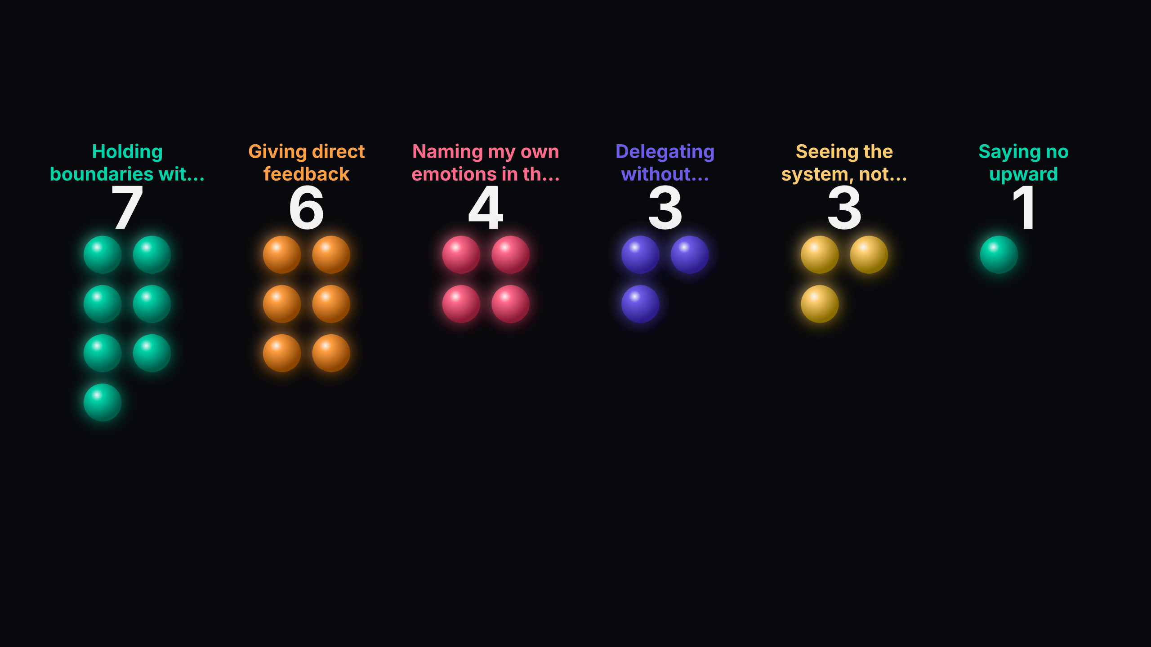
Poll 2: 24 votes
Practice is shifting where it matters: 'Holding boundaries with my own time' leads at 29% with 'Giving direct feedback' close at 25% (4pp gap). Gains are emerging across self and team, yet 'Saying no upward' sits at 4%, a small but strategic gap that echoes later permission signals. Treat as: rehearse upward boundaries and direct feedback in pairs. Pair participants this week to script and rehearse a 90‑second 'no upward' and one direct-feedback open.
3. Closely contested avoidance: 'underperformer' (24%) edges 'role boundaries with my manager' (19%) — pick one and rehearse live.
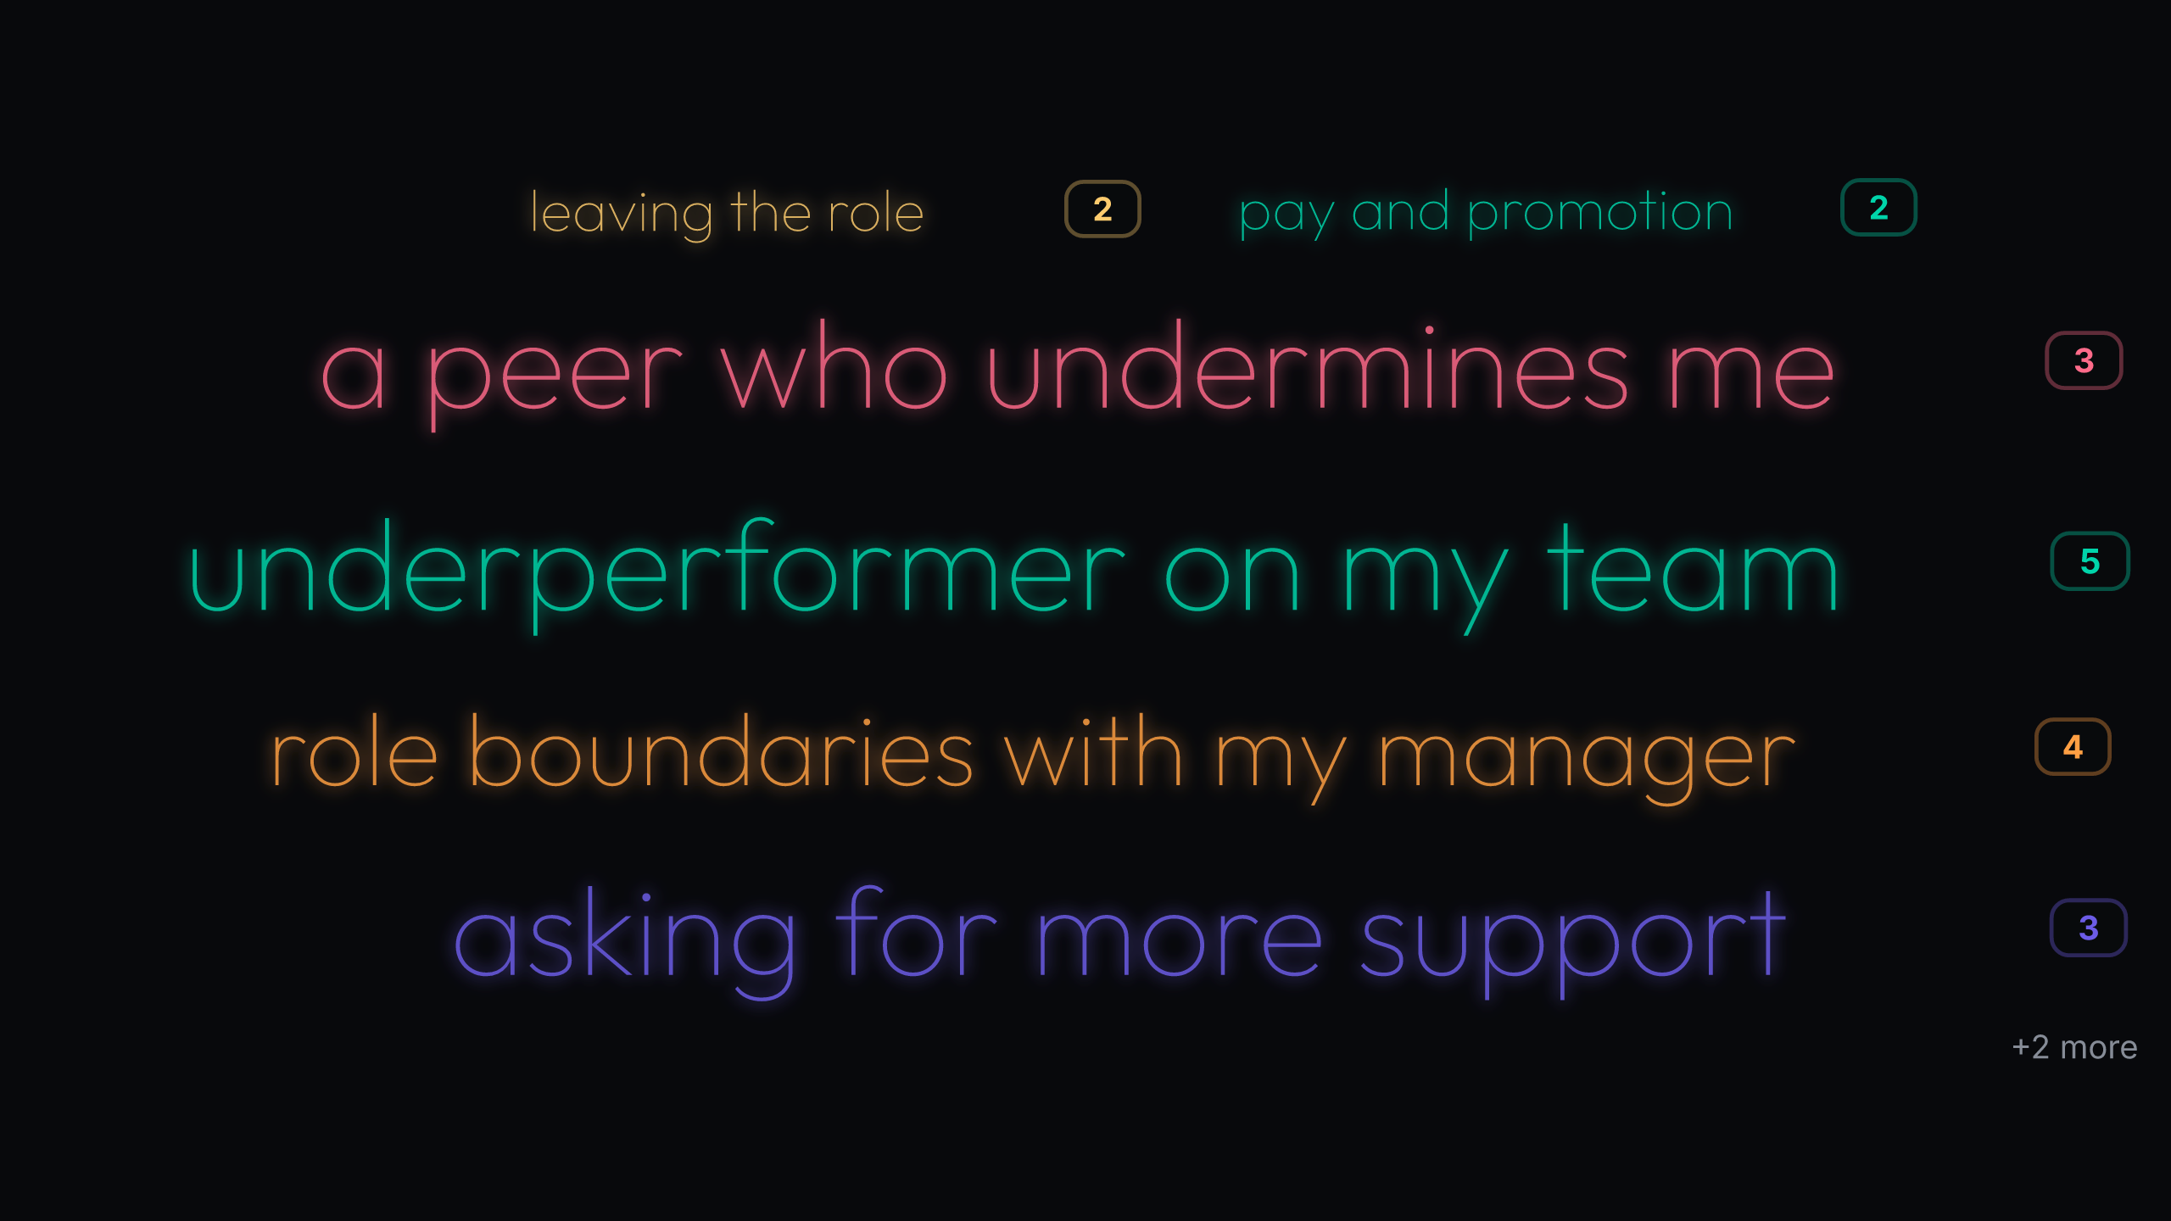
Poll 3: 21 votes
Avoided conversations cluster in two places: managing underperformance (24%) and upward role boundaries (19%), with peer politics (14%) and self‑advocacy (14%) close behind. The spread (head 3 combined 57%) says avoidance isn’t about one script; it’s about permission plus reps. Treat as: mirror the two hotspots and run paired rehearsals on one of them now. Name 'underperformer' and 'role boundaries with my manager' as today’s practice lanes; invite each person to choose one and rehearse.
4. Clear preference at 39%: 'I keep waiting for permission' — program should validate agency and script first steps.
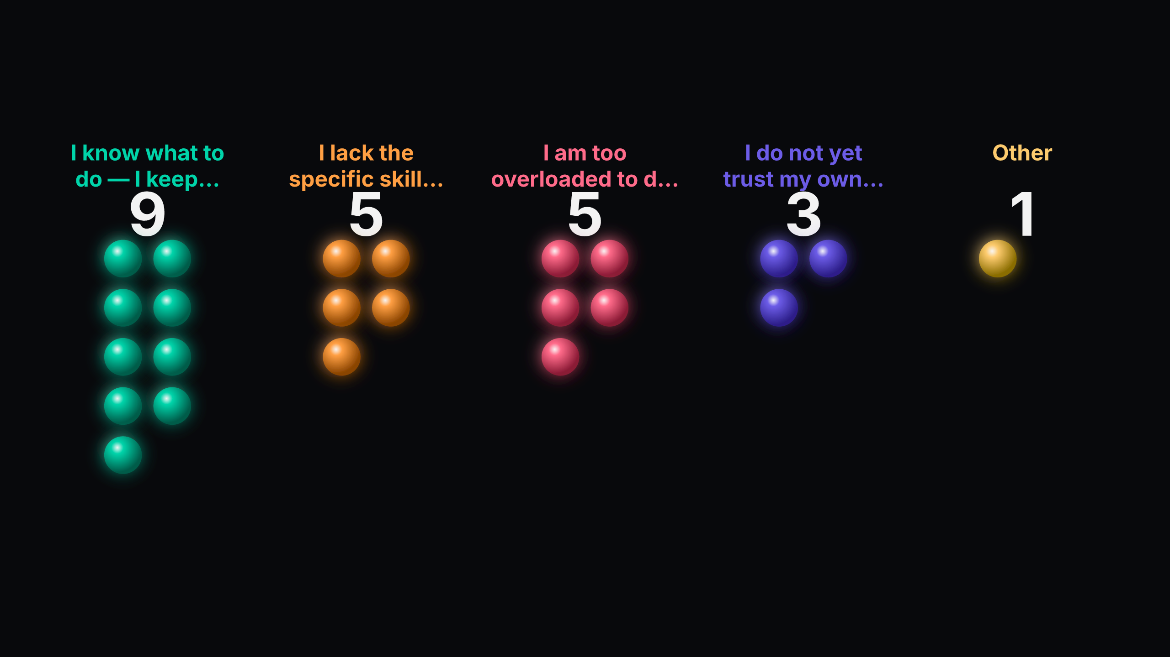
Poll 4: 23 votes
Permission is the primary gap at 39% (17pp over skill and capacity, both 22%), not knowledge. A further 13% don’t yet trust their judgment, which rhymes with the minority ask for explicit permission later on. This isn’t a content problem; it’s an action‑under‑authority problem. Treat as: validate agency explicitly and rehearse permission‑light moves. Mirror the permission gap explicitly and run a short 'permission you already have' exercise before any new content.
5. Moderate lead for peer rehearsal at 33% (8pp over coaching) — the room wants reps before more models.
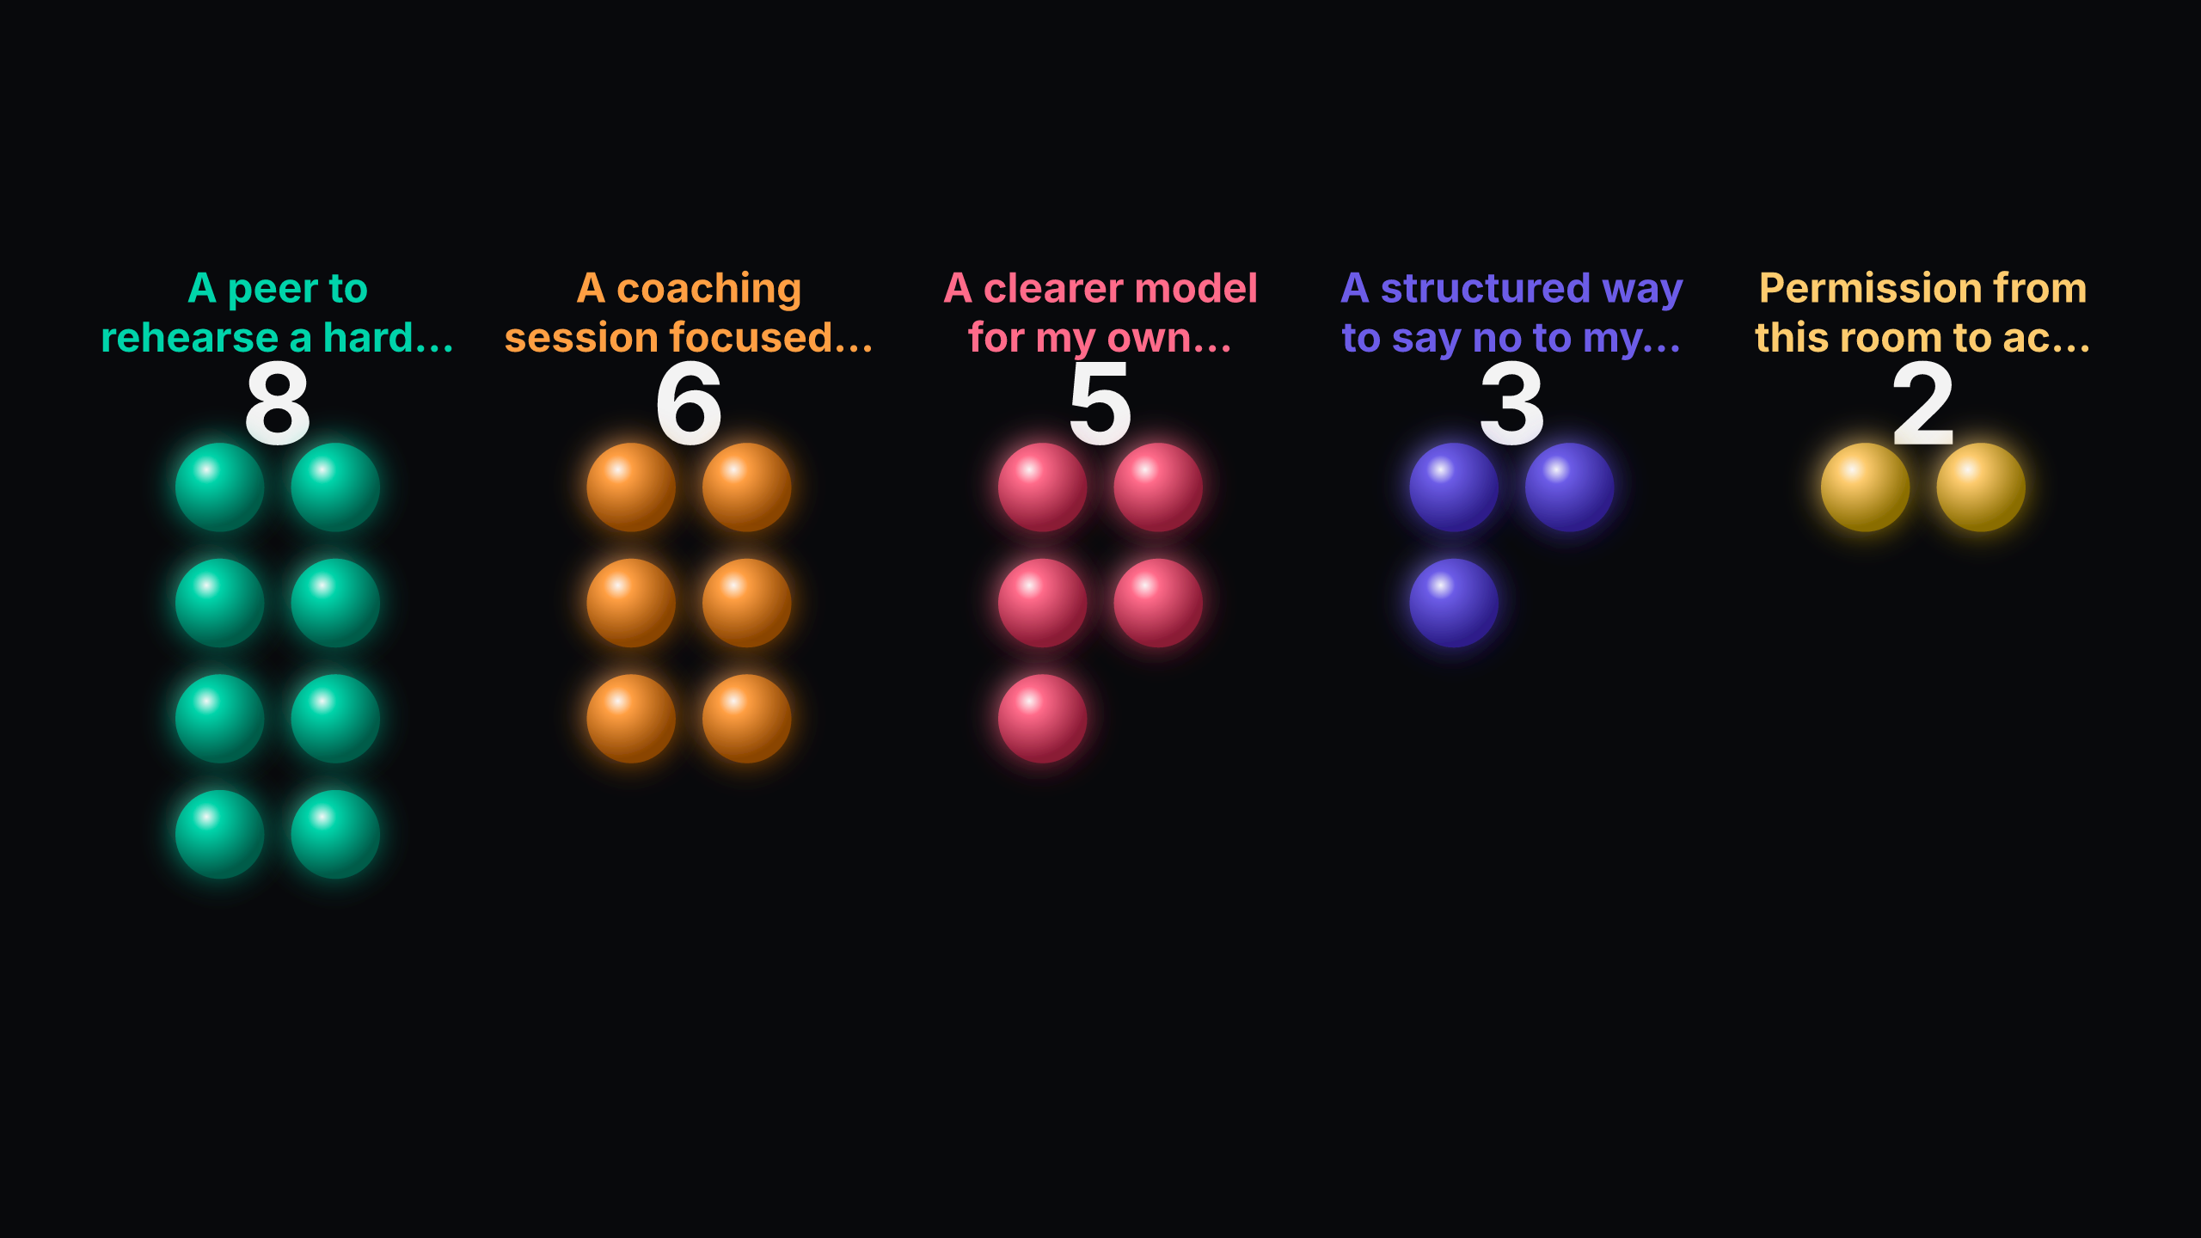
Poll 5: 24 votes
Practice support tops content: 'A peer to rehearse a hard conversation with' leads at 33% (8pp over a focused coaching session at 25%). 'A clearer model for my own decision‑rights' at 21% and 'A structured way to say no to my manager' at 13% translate the permission theme into tools. Only 8% asked for 'Permission from this room to act,' reinforcing that confidence grows through doing. Treat as: fund paired rehearsal and time‑boxed coaching slots. Pair participants for immediate rehearsal and offer short coaching office hours; include a one‑pager on decision‑rights and a 'saying no upward' script.
3. Where the room aligned
These cross-poll patterns are the clearest signals to act on.
• Avoided conversations map directly to the top support ask (high confidence). Performance and upward-boundary talks are the hardest and the room wants peer practice, not more content.. So what: Pair participants now and schedule two rehearsal blocks before the next session. Evidence: underperformer on my team — 24% (5/21); role boundaries with my manager — 19% (4/21); A peer to rehearse a hard conversation with — 33% (8/24).
• Permission gap explains demand for decision-rights and 'saying no' tools (high confidence). Stalling on action stems from authority ambiguity more than missing know-how.. So what: Introduce a one‑page decision‑rights model and rehearse a 'no upward' script in pairs. Evidence: I know what to do — I keep waiting for permission — 39% (9/23); A clearer model for my own decision-rights — 21% (5/24); A structured way to say no to my manager — 13% (3/24).
• Strained mood increases the return on peer connection (medium confidence). Feeling stretched/questioning and some isolation make peer rehearsal a support as well as a skill builder.. So what: Set up fixed peer pairings and a weekly 15‑minute check‑in cadence. Evidence: stretched — 25% (6/24) and questioning — 21% (5/24); isolated — 8% (2/24); A peer to rehearse a hard conversation with — 33% (8/24).
4. Where the room split
Execution confidence vs. Strained energy vs.
• Execution confidence vs. permission barriers: People know what to do but stall without felt authority; until this is handled, skill gains won’t translate into action. (high confidence). How to frame it: Mirror the permission signal and invite each participant to claim one action they already have authority to take; then rehearse 'saying no upward' in pairs. Evidence: I know what to do — I keep waiting for permission — 39% (9/23); A clearer model for my own decision-rights — 21% (5/24); A structured way to say no to my manager — 13% (3/24).
• Strained energy vs. improving practice: Energy is low while skills are moving; without peer support, strain can blunt the gains. (medium confidence). How to frame it: Validate 'stretched' out loud, then convert improvements into quick wins by pairing people to run one real conversation this week. Evidence: stretched — 25% (6/24) and questioning — 21% (5/24); Holding boundaries with my own time — 29% (7/24); Giving direct feedback — 25% (6/24).
5. Next steps
5.1 Suggested directions
Based on the room's input, the team might consider:
• Which hard conversation will you commit to run before the next session?
• Open the next session by mirroring 'stretched'/'questioning' back to the room and inviting one specific permission each person will claim this week; debrief in 10 minutes.
• Create peer triads today for weekly 15‑minute check‑ins; have each triad log one action taken between sessions.
• Assign partners now; each writes a two‑line 'no upward' boundary and a 20‑second feedback opener, rehearses twice, and runs one real conversation before next session; debrief next time.
5.2 Specific commitments from the room
Use this space to record what your team agreed to in the room — owners, dates, and follow-ups CrowdHum couldn't see.

